**كلية الحاسبات و الذكاء الاصطناعى**

**Pharmacy DB**

**BY**

**Mohamed Ashraf Omara**

**Ola Farhat Ibrahim**

**Wafaa Gamal Okasha**

**Salma Yasser Mostafa**

**Supervisor**

**ENG/ Ahmed Abdelsalam**

**DR/ Asmaa Saad**

**ACKNOWLEDGMENTS**

First and foremost, I would like to thank the chairman of our committee, **Dr/ Ahmed Abdel Salam**, for his support, outstanding guidance and encouragement throughout my senior project.

**Acknowledgments to Team Members**

I would like to express my deepest gratitude and appreciation to my incredible team members who have contributed their time, skills, and dedication to our project. Working alongside each of you has been an enriching and rewarding experience, and I am grateful for the opportunity to collaborate with such talented individuals. Together, we have achieved remarkable milestones and overcome numerous challenges.

First and foremost, I would like to thank [**ENG/Mohamed Omara**] for their exceptional leadership and guidance throughout the project. Your expertise and strategic thinking have been invaluable in steering our team towards success. Your ability to motivate and inspire us has played a crucial role in keeping the team focused and driven.

I would also like to extend my appreciation to [**ENG/Salma Yasser**], whose creativity and innovative ideas have brought a fresh perspective to our project. my contributions have sparked new avenues of exploration and have been instrumental in pushing the boundaries of our work.

Furthermore, I want to acknowledge the hard work and dedication of [**ENG/Ola Farhat**]. Your meticulous attention to detail and analytical mindset have greatly contributed to the precision and accuracy of our project. Your commitment to excellence has set a high standard for the entire team.

I am also grateful to [**ENG/Wafaa Gamal** ] for their strong work ethic and unwavering commitment. Your willingness to go above and beyond expectations has been truly inspiring. Your ability to tackle challenges head-on and find solutions has been instrumental in our achievements.

Last but not least, I would like to express my gratitude to the rest of the team members for their hard work, dedication, and valuable contributions. Each of you has brought unique skills and perspectives to the table, enriching our project and making it stronger.

I am truly honored to have worked with such an amazing team. Your commitment, professionalism, and camaraderie have made this journey memorable and enjoyable. Our collective efforts and collaboration have laid the foundation for success, and I am confident that we will achieve even greater accomplishments in the future.

**Thank you all for being an integral part of this team and for your unwavering support**

**List of tables :**

**Table 1.1** Abbreviations ……………………………………………….….….4

**Table 2.1** Abstract …….…………..……………..….……………….………...5

**Table 3.1** Tools of Microsoft access ……..............................…7

**Table 4.1** Customers……………………………...………..…..………………9

**Table 5.** Employees………….…...……….…………............................9

**Table 6.1** Invoices.…………………….…………………………....…………10

**Table 7.1** Products…..………….…………...…………..….……………….10

**Table 8.1** Sales ………………..…….……….………….……………………..11

**Table 9.1** Queries………………….…….…...…..…..………………………12

**Table 10.1** Conclusion………………….…….…...…..…..………………………13

**Table 11.1** Refrences………………….…….…...…..…..………………………14

**Abbreviations**

|  |  |
| --- | --- |
| Abreviation | Definition |
| DBMS | Data base management system |
| CS | Computer science |
| ERD | Entity Relationship Diagram |
| COM | common object model [Microsoft] |
| IS | information services |
| ID | Identity document |
| DB | Database |
| IS | Information system |
| IT | Information technology |
| WWW | world wide web |
| ERP | enterprise resource planning |

**Abstract**

The Pharmacy Database Management System (DBMS) project focuses on developing an efficient and comprehensive database infrastructure for managing entities within the Faculty of Pharmacy. The project aims to streamline the storage, retrieval, and manipulation of data related to customers, invoices, employees, and products, enhancing the overall efficiency and effectiveness of pharmacy operations.

The DBMS encompasses essential functionalities required for entity management within a pharmacy setting. It includes data organization, data integrity, query processing, and data security mechanisms. By leveraging database technologies, the system provides a centralized repository for storing and managing information, facilitating smooth operations and optimizing decision-making processes.

For customers, the DBMS provides features such as customer profile management, prescription records, and medication history tracking. It enables the efficient retrieval of customer information for personalized services and facilitates the processing of prescription orders. Invoices and billing information are stored and managed within the system, allowing for accurate tracking of transactions and timely billing processes.

Employee management functionalities within the DBMS support various aspects of human resources management, including employee profiles, work schedules, and performance evaluations. The system facilitates efficient communication and coordination among employees, ensuring effective teamwork and customer service delivery. Additionally, it assists in tracking and managing employee qualifications, certifications, and training records.

Product management is a crucial aspect of the pharmacy DBMS, enabling effective inventory control and supply chain management. The system provides tools for tracking product information, including stock levels, expiration dates, and supplier details. By integrating with suppliers' databases, the system enables seamless ordering and inventory replenishment processes.

Data integrity is maintained through the implementation of constraints and validation rules, ensuring accurate and consistent data entry. The system supports efficient query processing, enabling users to retrieve relevant information based on specific criteria, such as customer preferences or product availability. The DBMS also incorporates data security measures, including user authentication, access controls, and encryption, to protect sensitive information and comply with privacy regulations.

User-friendly interfaces are designed to facilitate data entry, retrieval, and manipulation, ensuring ease of use for pharmacy staff. The system includes features such as intuitive forms, search functionalities, and data visualization tools to enhance usability and support data exploration. Furthermore, the DBMS supports scalability and performance optimization techniques to accommodate increasing data volumes and user demands as the pharmacy expands.

**Definitions About Tools of Microsoft access**

ERD (Entity-Relationship Diagram) is a modeling technique that is used to design and represent the relationships between different entities or objects in a database. The main components of an ERD include entities, attributes, and relationships.

**1. Entities:**

An entity represents a real-world object, concept or thing that is relevant to the system. It can be a physical object such as a car, a person, a place, or an abstract concept such as an account, a transaction, or an order. In an ERD, entities are represented as rectangles with the name of the entity written inside it.

**2. Attributes:**

An attribute is a characteristic or property of an entity. It describes the features, qualities, or characteristics of the entity. For example, the attributes of a person entity may include name, age, address, phone number, and so on. In an ERD, attributes are represented as ovals connected to the entity they belong to.

**3. Relationships:**

A relationship is a connection between two or more entities. It describes how the entities are related to each other. For example, a relationship between a person entity and a car entity can be "owns" or "drives". In an ERD, relationships are represented as diamond shapes, connecting the related entities.

**The functions of ERD include:**

**1. Planning and Designing:** ERD is an essential tool for planning and designing a database system. It helps to identify the entities and their relationships, and determine the attributes needed for each entity. This ensures that the database is organized and efficient.

**2. Communication:** ERD provides a clear and concise way to communicate the design of a database system to stakeholders such as developers, designers, and end-users. It helps to ensure that everyone involved in the project has a common understanding of the database structure and the relationships between different entities.

**3. Maintenance:** ERD can also be used to document the database system for future maintenance and upgrades. It provides a visual representation of the database structure that can be used to modify and update the system as needed.

Overall, ERD is an important tool for designing, communicating, and maintaining a database system. It helps to ensure that the system is well-organized, efficient, and easy to understand and use.

Microsoft Access is a database management system that allows users to store, organize, and manage data. It provides a variety of tools and features to help users create and maintain databases, **including:**

**1. Tables:** A table is a basic component of any database. In Access, a table is used to store data in rows and columns, similar to a spreadsheet. Users can create tables, define the fields and data types, and add, edit, or delete data.

**2. Forms:** A form is a user interface that allows users to enter and view data in a table. Users can create forms that include fields from one or more tables, add buttons and other controls, and customize the layout and appearance of the form.

**3. Queries:** A query is a search or question that retrieves data from one or more tables in the database. Users can create queries to find specific data, sort and filter data, calculate values, and summarize data.

**4. Reports:** A report is a formatted output of the data in a table or query. Users can create reports to print or view data in a professional format, such as a summary report or a chart.

Overall, Microsoft Access provides a range of tools and features to help users create and manage databases. Each tool has its own purpose and can be used together to create a complete database system that meets the needs of the user.

**Table 1.1 Customers**

**Table 2.1 Employees**

**Table 3.1 Invoices**

**Queries**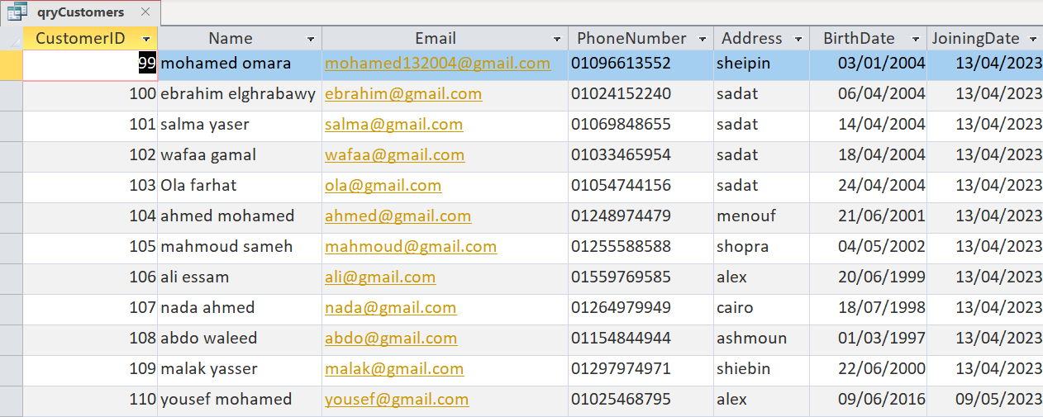

**Conclusion**

In summary, the Pharmacy Database Management System provides a comprehensive and secure platform for managing entities within the Faculty of Pharmacy. By leveraging efficient data organization, integrity, and security measures, the system enhances pharmacy operations related to customers, invoices, employees, and products. The DBMS supports efficient workflows, promotes accurate record-keeping, and facilitates informed decision-making within the pharmacy environment.

**References**

* Mongodb.local NYC
* Europa.eu
* Wikipedia
* Chat gpt
* Codeigniter
* Oracle